Question: 1
Remove the side panel of a desktop PC case and take a clear photo showing the internal layout before any components are removed.

Answer: 1
Desktop PC Internal Layout Examination
Before removing any hardware components from the desktop PC chassis, I safely unscrewed and removed the side panel to thoroughly inspect the untouched internal layout and cable routing. 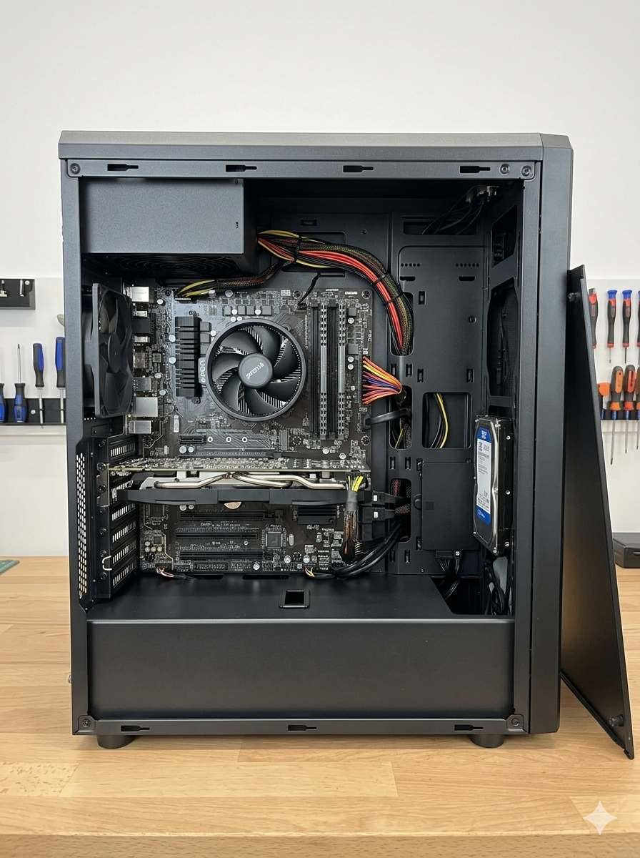

Question: 2
Carefully remove the RAM module(s) from the motherboard, document the removal steps, and record the RAM type, speed, and form factor as printed on the module.

Answer: 2

Steps to Remove RAM from the Motherboard
- Turn off the computer: Shut down the PC completely and unplug the power cable from the wall.
- Open the computer case: Remove the side panel of your PC case using a screwdriver to see the motherboard.
- Locate the RAM slots: Find the long vertical slots next to the CPU processor.
- Press the side clips: Push down the small plastic clips at both ends (or just one end) of the RAM slot. The RAM module will pop up slightly.
- Pull out the RAM: Hold the RAM module by its edges and gently pull it straight out of the slot. Do not touch the gold metal pins.

Question: 3
Disconnect and remove the storage drive (HDD or SSD) from the system, then list all connector types (SATA, power, etc.) used and describe how the drive was mounted inside the case.<br><br><em><strong>Hint:</strong> Pay attention to both cable connectors and any brackets or screws securing the drive.</em>

Answer: 3

Steps to Remove the Storage Drive
- Power off and unplug: Turn off the computer completely and disconnect the power cord from the wall.
- Disconnect the cables: Gently pull out the data cable and the power cable from the back of the storage drive (HDD or SSD).
- Unscrew or unlatch the drive: Remove the screws securing the drive to the drive bay, or release the plastic latch if it uses a tool-less tray.
- Slide the drive out: Carefully slide the storage drive out of its mounting slot inside the computer case.

Storage Drive Connector Types
- SATA Data Connector: A flat, 7-pin data cable that connects the hard drive or SSD to the motherboard.
- SATA Power Connector: A wider, 15-pin cable coming from the Power Supply Unit (PSU) to provide power to the drive.

How the Drive is Mounted Inside the Case
- Drive Bays: Storage drives are placed inside specific metal cages or slots called drive bays (3.5-inch for HDDs and 2.5-inch for SSDs).
- Mounting Screws: The drive is held firmly in place using small screws on the sides or bottom to stop it from vibrating.
- Tool-less Brackets (Optional): Some modern cases use plastic trays or caddies that snap onto the drive without screws, allowing it to slide directly into the cage.

Question: 4
Identify and remove one expansion card (such as a graphics card or Wi-Fi card), then document the connector type (e.g., PCIe), screw type used, and any locking mechanisms you encountered.

Answer: 4

Steps to Remove the Expansion Card (Graphics Card)
- Power off and unplug: Turn off the computer completely and unplug the power cord from the wall.
- Remove the side panel: Open the computer case to access the internal components.
- Disconnect external cables: Unplug any video cables (like HDMI or DisplayPort) connected to the back of the card.
- Unscrew the bracket: Remove the screw that secures the card's metal bracket to the computer case.
- Release the locking clip: Press down the small plastic latch at the end of the motherboard slot to unlock the card.
- Pull out the card: Hold the graphics card firmly by its edges and pull it straight out of the slot.

Expansion Card Details
- Connector Type: PCIe (PCI Express) slot, which is the standard long slot on the motherboard used for graphics cards.
- Screw Type: Phillips-head screw (or a standard case thumbscrew) used to secure the metal mounting bracket to the PC chassis.
- Locking Mechanism: A plastic retaining clip (latch) located at the right end of the PCIe slot that snaps into place to hold the card tightly.

Question: 5
Explain three safety precautions you followed during the disassembly process to prevent static electricity damage or injury, and describe how you ensured proper grounding.<br><br><em><strong>Hint:</strong> Mention tools or accessories like anti-static wrist straps, and steps like unplugging the power supply.</em>

Answer: 5

Three Safety Precautions Followed
Unplugging the Power Supply: Turned off the PC and fully removed the power cable from the wall outlet to prevent electric shock or short circuits.
Using an Anti-Static Wrist Strap: Wore an ESD (Electrostatic Discharge) wrist strap connected to a metal surface to safely release any static buildup from the body.
Handling Components by Edges: Held internal parts like RAM and graphics cards strictly by their plastic or metal edges to avoid touching sensitive gold pins and circuits.

How Proper Grounding Was Ensured
Touching Bare Metal: Kept the computer's metal chassis resting on a flat, non-conductive surface. Regular contact was maintained with unpainted sections of the metal case to ground any static charge before touching internal components.

